Object-Oriented Analysis & Design with Java

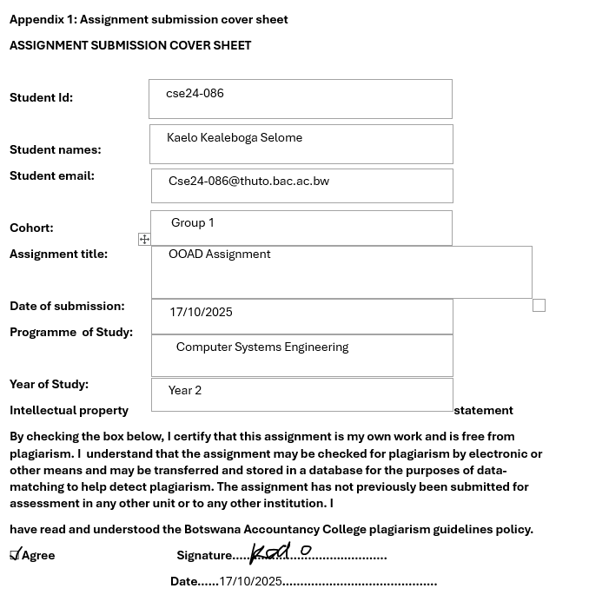

Requirements Elicitation

This section identifies and specifies the requirements of the Banking System.
Functional Requirements

- Allow a customer to register and log in.
- Allow a customer to open one or multiple accounts (Savings, Investment, or Cheque).
- Allow deposits into any account.
- Allow withdrawals from respective accounts (Investment and Cheque, but not Savings).
- Calculate and pay monthly interest (0.05% for Savings, 5% for Investment).
- Display account details (balance, account number, recent transaction history).
- Maintain a record of all transactions.
- Authorize account opening rules (minimum BWP500 for Investment, employer details for Cheque).
- Print a receipt after each transaction.

Non-Functional Requirements

- Security: Customer data and transactions must be protected.
- Performance: Transactions should be processed within seconds.
- Reliability: All transactions must be accurately saved without data loss.
- Usability: The GUI must be simple for non-technical users.
- Portability: The system should run on any machine with Java installed.
- Maintainability: Separation of concerns between GUI, controller, and business logic layers.
- Scalability: The system should support many customers and accounts as the bank grows.
- Data Integrity: All account and customer data should be stored in the database and updated if altered with during transactions.

Structural UML Modelling

Use Case Diagram

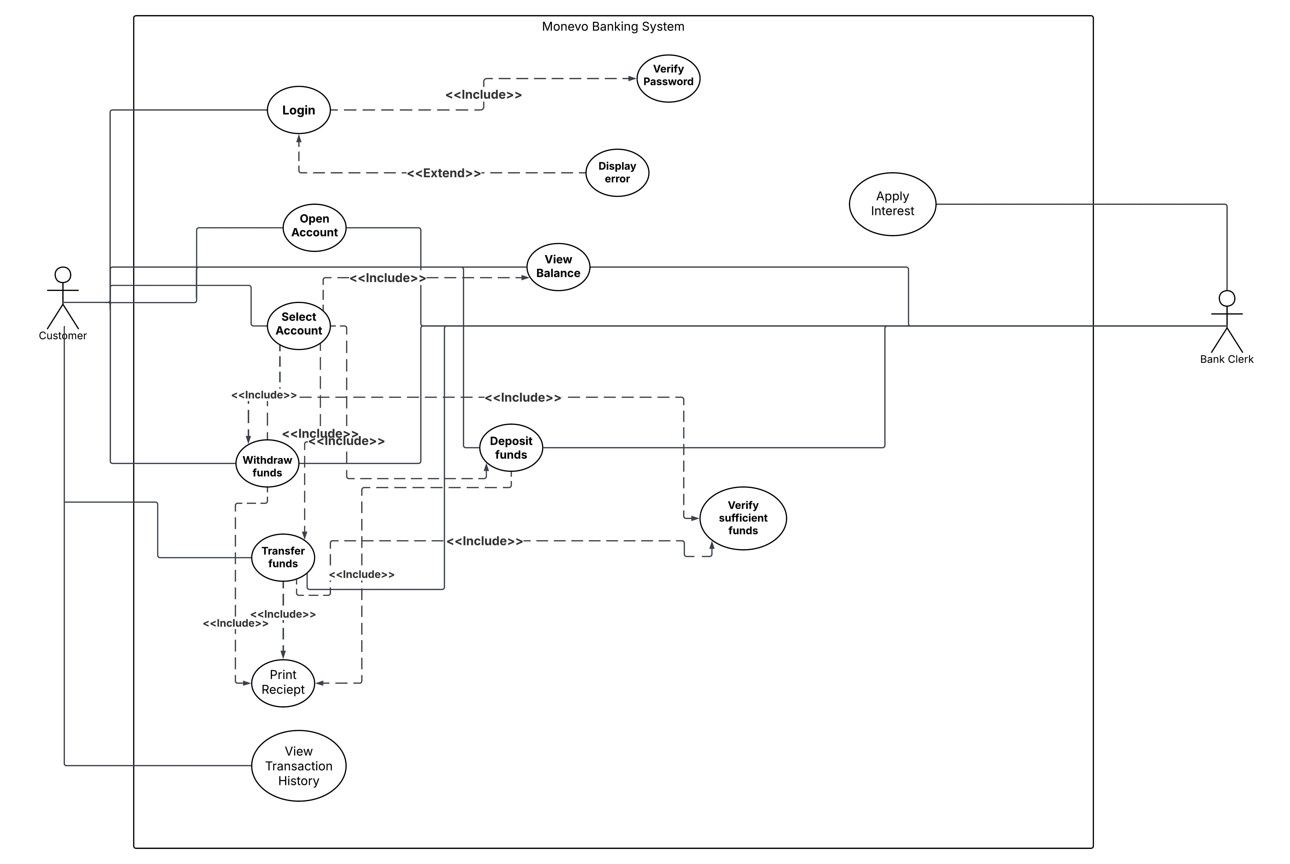

Class Diagram


Behavioral UML Modelling

Sequence Diagrams
Deposit Funds
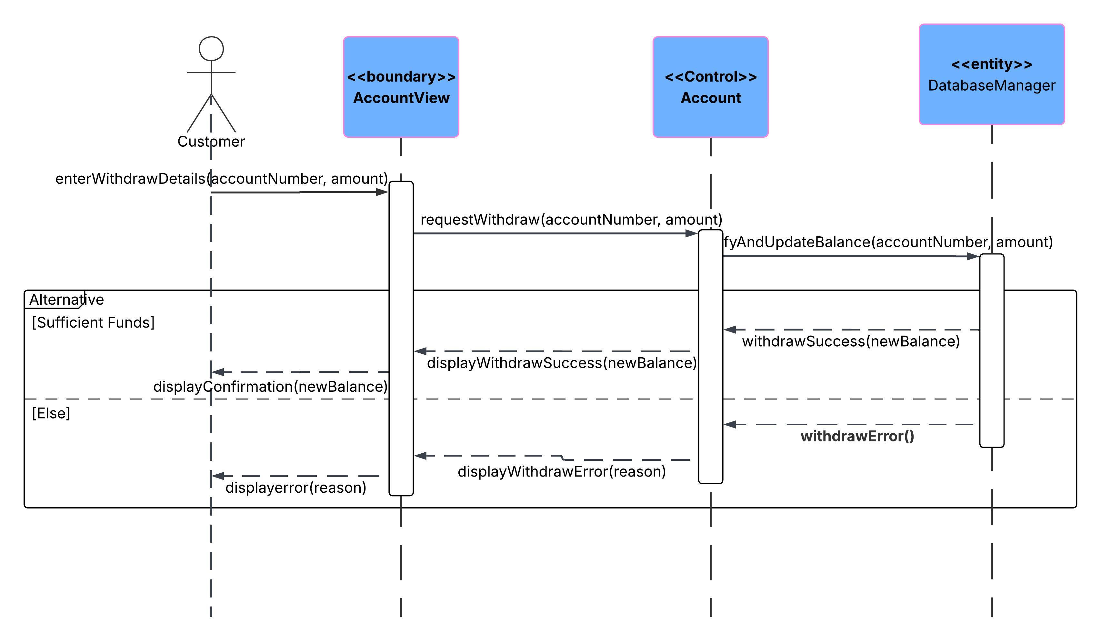

Login
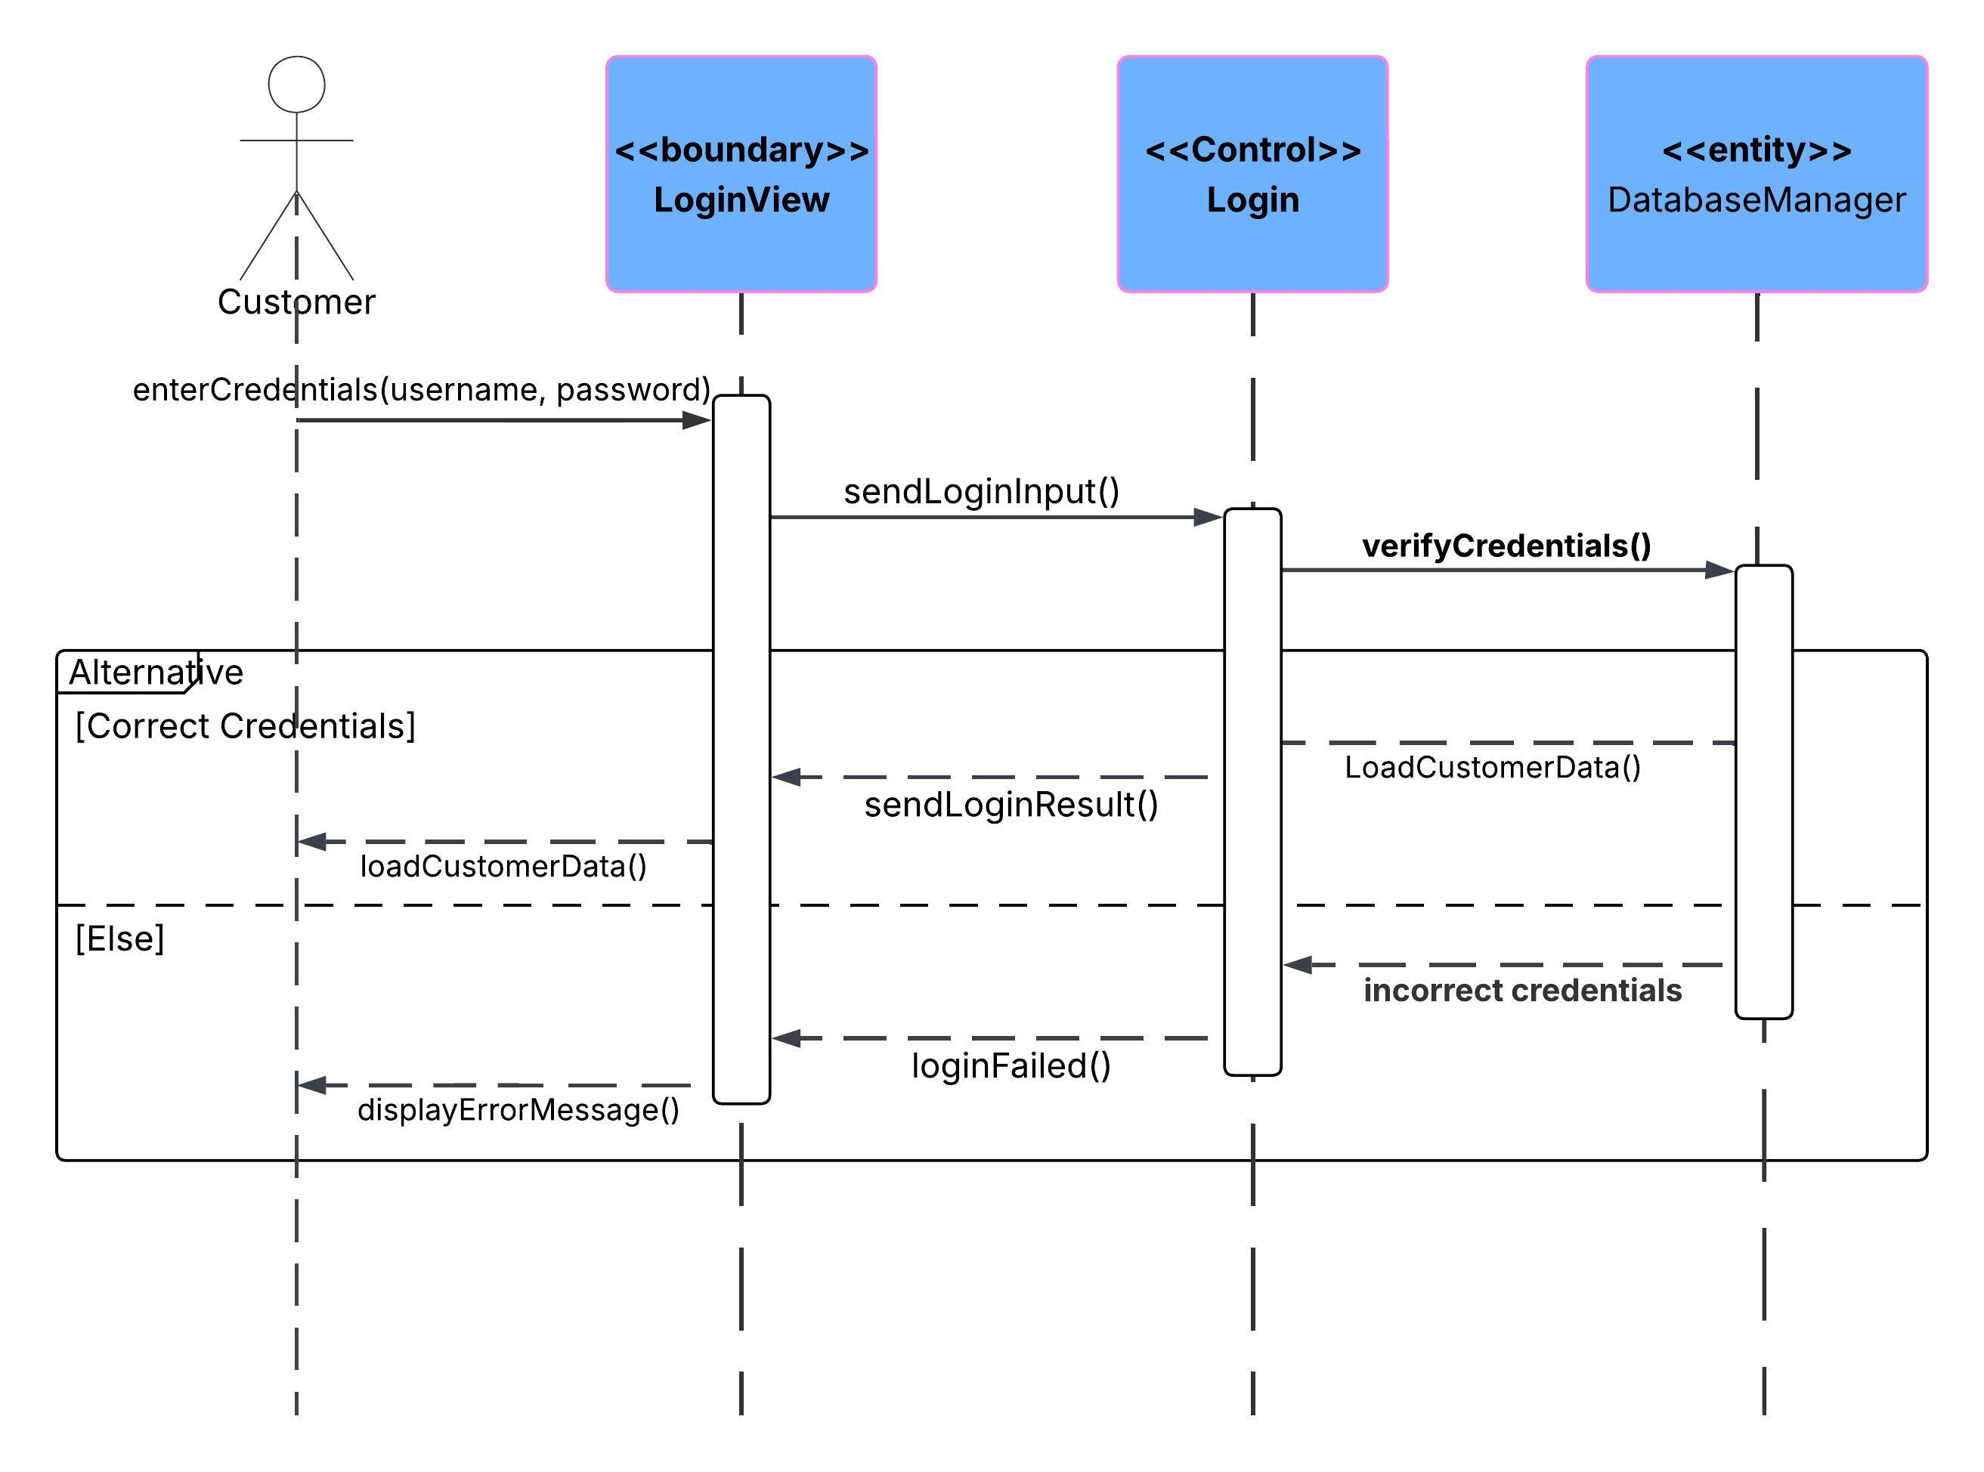

State Diagram

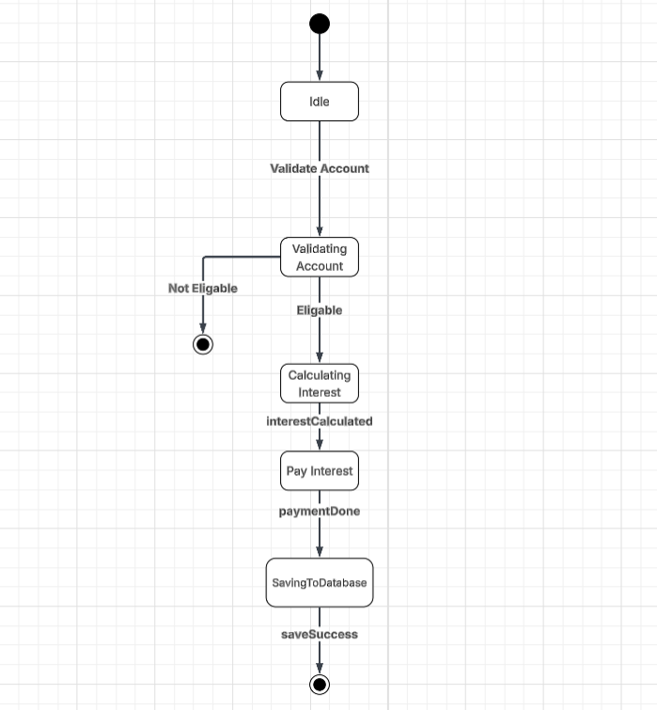

Date: 18 Sept 2025
Interviewer: Kaelo Kealeboga Selome
Interviewee (Client): Mr Themba Moeng (acting as bank manager)
Purpose: To gather functional and non-functional requirements for the banking system.

Q1: What are the core services this bank system should provide?
A: The system should allow customers to register with the bank, open accounts, deposit money, withdraw and deposit money (where applicable), and check their account balances.
Q2: What performance is expected from the system?
A: The system should be smooth and responsive and only take a few seconds to perform transactions.
Q3: How is interest supposed to work?
A: Savings Account earns 0.05% monthly interest, while Investment Account earns 5% monthly interest. The system must automatically calculate and apply interest monthly.
Q4: Should there be any restrictions when opening an account?
A: Yes, Investment Account must have an initial deposit of at least BWP500. Cheque Account requires employer information.
Q5: What should the system do when a customer makes a transaction?
A: It should validate the account, update the balance, and store the transaction details in a database for record keeping.
Q6: Are there any special quality requirements?
A: The system should be secure, reliable and user-friendly.
Q7: Are there any extra features you would like?
A: I advise you to stick to the scope to maintain the timeline but you are free to add one or two like transfer funds if you can maintain the timeline.
Q8: Should all account data be stored permanently?
A: Yes, all account data should be stored permanently in a database so as to maintain data integrity.
Part B: System Implementation Documentation

Project Structure Overview
The project structure of the Monevo Banking System is organized into various modules, each serving it’s respective task in the development of the system.
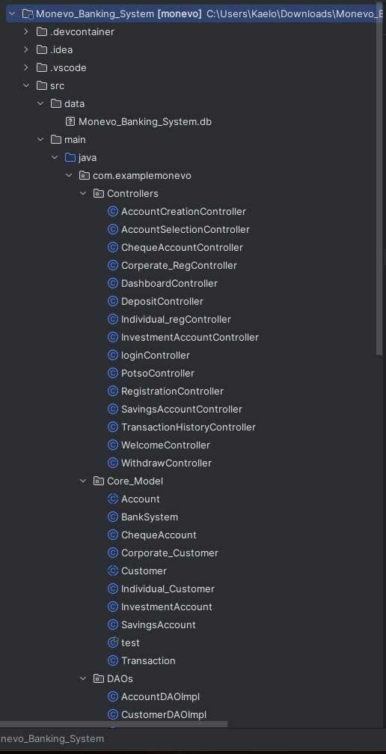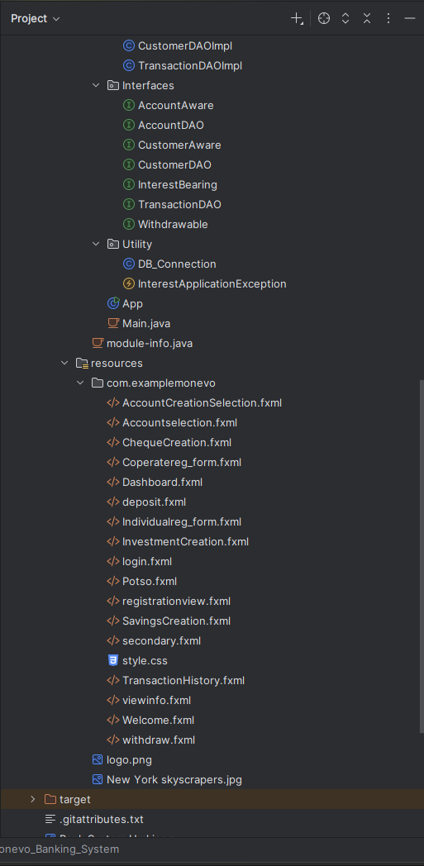
Controllers
The Controllers are the Java classes that manage the flow of the application, acting as a bridge between the user interface and the business logic. Each controller is responsible for handling specific actions like user authentication or account creation.

- AccountCreationController.java: Handles account creation functionality.

- DepositController.java: Manages deposit transactions.

- LoginController.java: Controls the login process.

- WithdrawController.java: Manages withdraw transactions.

- DashboardController.java: Responsible for the actions performed in the dashboard.

- Individual_regController.java: Ensures registration for individual customers in the system.

- Corporate_RegController.java: Handles registration for company customers in the system.

- InvestmentAccountController.java: Enables registration form for the Investment account.

- ChequeAccountController.java: Responsible for registration form for the cheque account.

- SavingsAccountController.java: Enables registration form for the savings account.

- TransactionHistoryController.java: Handles actions taken on the history page.

- AccountCreationController.java: Handles the actions performed on the

- AccountCreation page: Manages account creation.

Core Model (Business Logic)
The Core Model of the banking system consists of the main entities that represent the business logic, including accounts, customers, transactions, and more.
Account Class
- Purpose: The Account class represents a bank account, including properties like balance, account number, and transactions.
- Attributes:
  - accountNumber
  - balance
  - accountType
  - customer
- Key Methods:
  - deposit(amount)
  - withdraw(amount)
  - getBalance()
- Relationships:
  - This class interacts with Customer since an account is always owned by a customer.
  - It acts as a parent class to subclasses like SavingsAccount, ChequeAccount and InvestmentAccount.

Customer Class
- Purpose: Represents a customer in the banking system. A customer can own one or multiple accounts
- Attributes:
  - customerID
  - firstName
  - lastName
  - address
- Key Methods:
  - addAccount(account
  - getAccount()
- Relationships:
  - This class is associated with the Account class, as each customer can have multiple accounts.
Transaction Class
- Purpose: The Transaction class manages transactions such as deposits and withdrawals. It keeps track of the transaction type, amount, and the date it happened.
- Attributes:
  - transactionID
  - transactionType
  - amount
  - date
- Key Methods:
  - getTransactionDetails()
- Relationships:
  - This class relates with Account to process deposits or withdrawals. Each transaction affects the balance of an account.

SavingsAccount Class
- Purpose: The SavingsAccount class represents a type of account that pays interest on the balance and does not withdraw and extends the Account class.
- Attributes:
  - interestRate
- Key Methods:
  - calculateInterest()
  - deposit(amount)
- Relationships:
  - Inherits from the Account class and therefore shares common account functionality.

InvestmentAccount Class
- Purpose: The InvestmentAccount class represents the InvestmentAccount.
- Attributes:
  - InitialDeposi
  - interestRate
- Key Methods:
  - Interest(): Calculates and applies interest to the account balance.
  - deposit(amount)
- Relationships:
  - Inherits from the Account class and adds additional functionality specific to investment accounts.

Data Access Object (DAO) Implementations
The DAO classes in the banking system manage the persistence layer, which handles communication with the database. These classes abstract the database operations, allowing the system to interact with data.

AccountDAOImpl

- Purpose: The AccountDAOImpl class implements the AccountDAO interface and provides the actual database operations for managing accounts.

- Methods:
  - createAccount(Account account)

  - getAccountById(int accountId)

  - updateAccount(Account account)

  - deleteAccount(int accountId)

  - getAllAccounts()

  - generateAccountNumber(String accountType)

  - getAccountBycustomerId(String customerId

  - recordInterestTransactions(String type, double rate, PreparedStatement txPs

- Relationships:
  - Interacts with the Account entity to perform all operations related to accounts.
  - Works with the DB_Connection class to connect to the database and execute SQL queries.

- CustomerDAOImpl
- Purpose: The CustomerDAOImpl class implements the CustomerDAO interface and provides database operations for managing customer data. It interacts with the database to store and gets customer details.

- Methods:
  - createCustomer(Customer customer)

  - getCustomerById(int customerId)

  - updateCustomer(Customer customer)

  - deleteCustomer(int customerId)

  - getAllCustomers()

  - login(String username, String password)

- Relationships:
  - This class works with the Customer entity to manage customer-related operations.
  - Utilizes the DB_Connection class to interact with the database.

TransactionDAOImpl

- Purpose: The TransactionDAOImpl class implements the TransactionDAO interface and provides database operations for managing transactions. It handles the CRUD operations related to transactions such as deposits, withdrawals, and transaction history.

- Methods:
  - createTransaction(Transaction transaction)
  - getTransactionById(int transactionId).
  - getAllTransactions()
  - getTransactionsByAccount(int accountId)
  - deleteTransaction(int transactionId)

- Relationships:
  - Interacts with the Transaction entity to perform all operations related to transactions.
  - Uses the DB_Connection class to connect to the database and execute queries.

GUI Technology and Design

- The graphical user interface (GUI) was built using JavaFX. The Classes (are defined using FXML files and correspond to the system's external requirements.

- Key Views: Welcome.fxml, login.fxml, registrationview.fxml, dashboard.fxml, deposit.fxml, withdraw.fxml, and account creation forms (Individualreg_form.fxml, InvestmentCreation.fxml, etc.).

- Design Rationale: The design adheres to modern usability standards with clear navigation, standardized components, and logical grouping of fields (e.g., registration forms are split by individual/corporate customers).

Interfaces

The aim of using interfaces is to achieve Abstraction in the system. They define contracts for specific behaviours.

InterestBearing:
  - Purpose: Defines a contract for any account type that is eligible to accrue and pay interest

  - Key Methods: calculateInterest(), applyInterest().

  - Implementing Classes: SavingsAccount, InvestmentAccount.

- Withdrawable:

  - Purpose: Enables withdrawing funds. This is crucial for
maintaining the rule that a SavingsAccount cannot allow withdrawals, therefore it does not implement this interface, while ChequeAccount and InvestmentAccount do.

  - Key Methods: withdraw(amount).

  - Implementing Classes: ChequeAccount, InvestmentAccount.

- AccountDAO / CustomerDAO / TransactionDAO:

  - Purpose: Defines the standard CRUD (Create, Read, Update, Delete) and a few custom contracts for the persistence layer.

(AccountDAOImpl), the system can switch databases (e.g., from SQLite to MySQL) without altering the Controller or Core Model code.

  - Key Methods: getAccountBycustomerId(String customerId), createAccount(Account account) etc.

  - Implementing Classes: AccountDAOImpl, CustomerDAOImpl, TransactionDAOImpl.

- AccountAware / CustomerAware:

Purpose: These are utility interfaces, typically used by Controllers or Services, to manage references to the current Account or Customer object. Basically passes the objects.

  - Key Methods: setAccount(Account), setCustomer(Customer).

  - Implementing Classes: Various Controller classes (e.g., DepositController, DashboardController).

Database Connectivity

Integrate a persistence layer into the system using JDBC to connect to a database and manage data storage.

Database Setup:
A local SQLite database was set up to store data for customers, accounts, and transactions. The schema was designed based on the class diagrams.

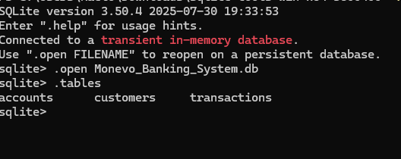

- JDBC Implementation:
  - DAO Classes: The AccountDAOimpl, CustomerDAOimpl, and TransactionDAOimpl classes were created to manage the database operations.
  - CRUD Operations: The DAO classes implement methods for creating, reading, updating, and deleting data in the database.

.

Database Connection:

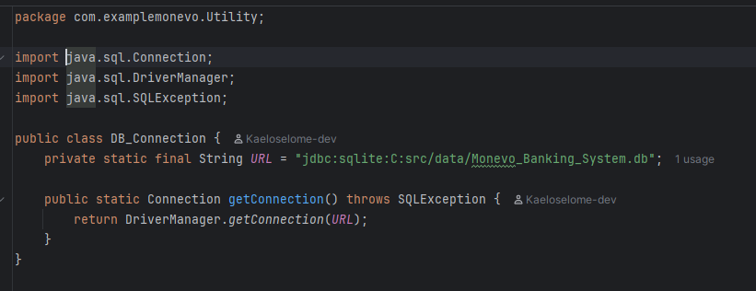

Testing and Integration

In this section, all modules (GUI, Controller, Core Model, and Database) were integrated into a single working application.

Full Integration:
The application was tested to ensure that all components work together seamlessly. The user can log in through the GUI, and the controller manages the flow to the core model, which performs the necessary transactions and updates the database.

Integration Testing
A short integration test was created to verify the complete user flow, including:

- Registration of new customer.

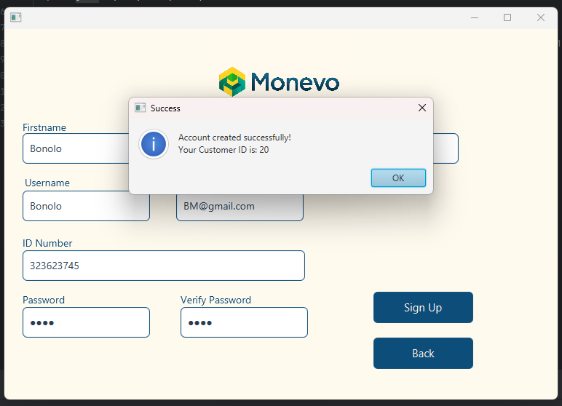

- Opening a new account for customer:

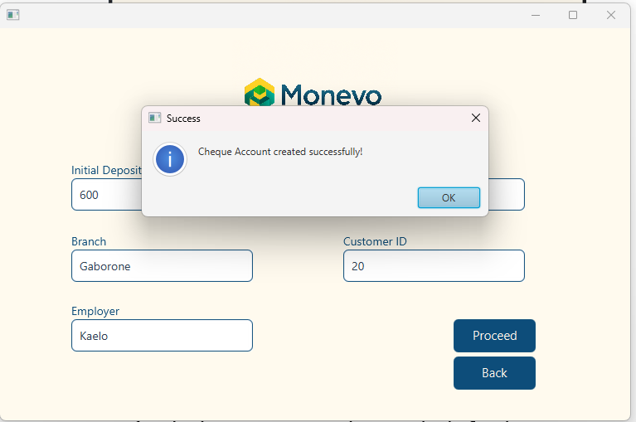

- Logging in through the GUI:

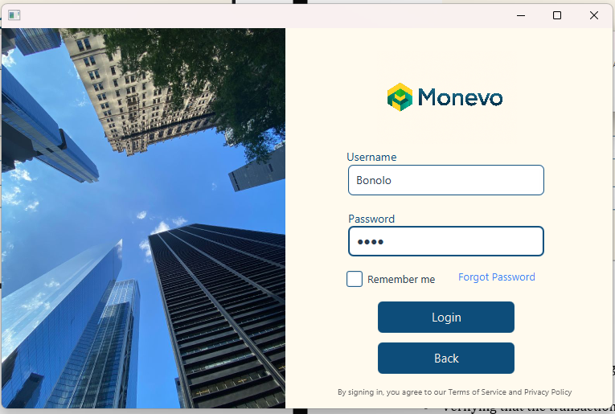

- Performing a transaction (e.g., deposit).
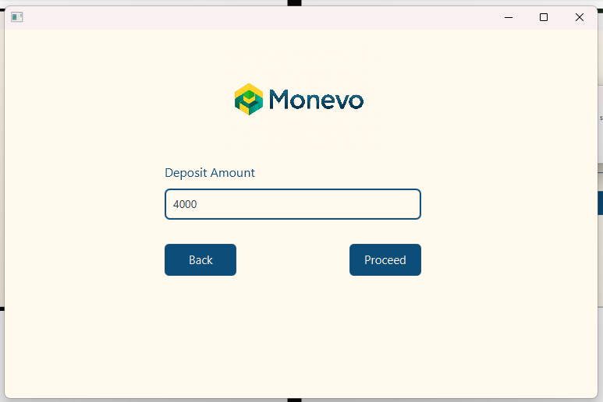

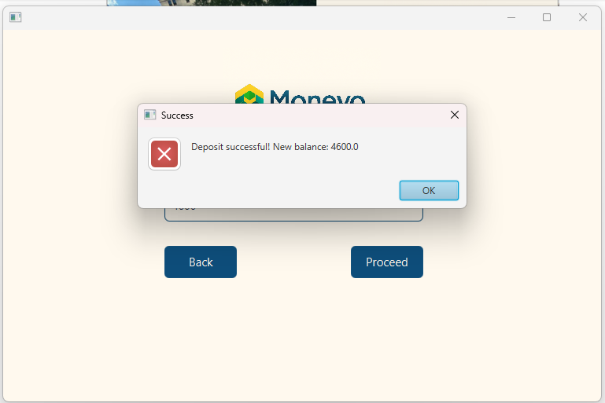

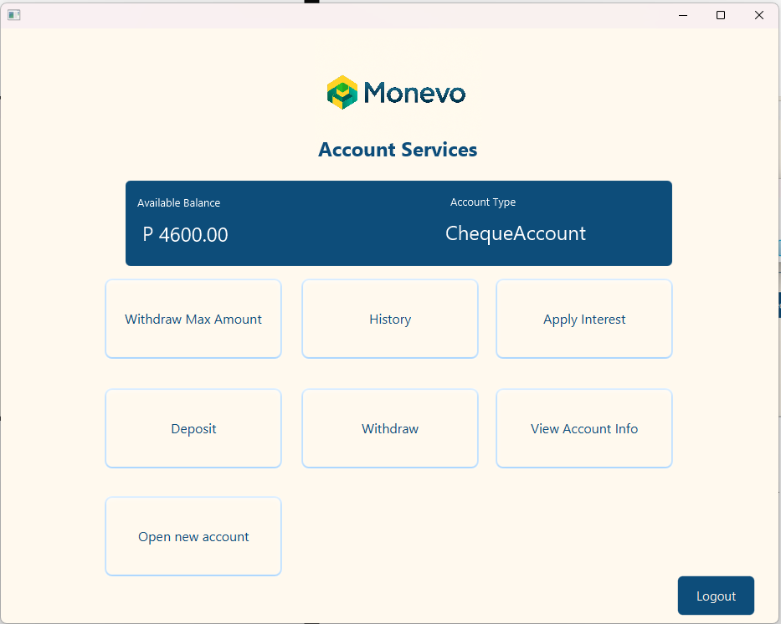

- Transaction saved in transaction history





